

ASSET VERIFICATION AND RECORDING TOOL KIT


Plot 31, Bukoto Street
P.O Box 7657, Kampala, Uganda
+256 (0) 39 2000216/0772525235
email: cpa@cpa.ug

www.cpa.com

August to September 2026

VERIFICATION DETAILS

NAME OF THE REGION: | WEST
SUB-REGION: | BUNYORO
Name of Local Government | KAKUMIRO
VERIFIER PARTICULARS
Full name | FATUMA YASIN,NAKAGWA HINDU,NAKITENDE SHARIFA
Contact/ email and Telephone | 0703480094  fatmayasin16@gmail.com
Supervisor/ Sub team leader | FATUMA YASIN
Name | DEPAUL
Contact | 0788483159
Date of submission

HEALTH CENTRES
INFORMANT INTERVIEW/DISCUSSION GUIDE (INCHARGE OR RESPONSIBLE PERSON)

Name of Health Centre: Birembo Health Centre III

1a | Does the Facility have a record of all assets provided under UgIFT.  (Obtain a record and verify if it has the costs and numbers supplied | YES
1b | If Not ask how many were supplied and when.

2

They repair some of them and the others are kept in the store.

3 | Does the facility take regular record about functionality/ or breakdown of the assets provided? | No, they have no record on breakdown of the assets provided. They are all recorded as a whole.

4 | How has the UgIFT support helped in service delivery in the area, any issues, challenges and any recommendations for better program implementation. | UgIFT has helped in the following ways;  - provided equipment to use which has improved the quality in service.  - They have helped with accommodation of staff .  - UGIFT constructed a whole maternity ward for women to easily give birth in the area.  Challenges;  - They have few structures to cater for the patients.  - They are not well conversant with the machines, so they keep them in the store.  - The facility lacks a fence which risks theft of the equipment.  Recommendations;  - Someone should train them on use of equipments.  - There is need to engrave the equipments.

PROCEED TO VERIFICATION AFTER THIS DISCUSSION

Health centre checklist

NAME OF LG………………………………………… NAME OF HEALTH FACILITY: Birembo Health Centre III

Equipment/ Item | Department | Asset Number | Item  Description | Life in Months | Tag Number ( engrave no.) | Date Of Purchase | Date Placed In Service | Recoverable cost | Cost | Acc Dep Cost | Net Book Value | Ytd Deprn | Equipment status | Remarks
B.P. Machine, Digital | MCH 01 |  | It is digital, grey in color |  | Not engraved | 14/11/25 |  |  |  |  |  |  | functioning | In use
02 | OPD 01
B.P. Machine (Aneroid wall mounted)
Autoclave 20 Liters.,Duo Operated
Bowl, Kick | Store |  | Silver basin like bowls |  | Not engraved | 14/11/25 |  |  |  |  |  |  | Still new | Not in use yet
02
Bowl Stand | Store |  | Silver basin like with wheel stands |  | Not engraved | 14/11/25 |  |  |  |  |  |  | Still new | Not yet in use
02
Counting chamber Neubauer- Improved
Cupboard Steel, Lockable | REC 01 |  | Grey in color with compartments and locks |  | Not engraved | 14/11/25 |  |  |  |  |  |  | functioning | In use
03 | MCH 01
 | LAB 01
Drip Stand |  |  | Silver with 2 hooks |  | Not engraved | 14/11/25 |  |  |  |  |  |  | functioning | In use
08 | MCH
ESR Stand
Examination Couch | Maternity  01 |  | Cream with a black bed |  | Not engraved | 14/11/25
02 | OPD 01
Examination light,LED | Store  01 |  | Black in colour |  | Not engraved | 14/11/25
02 | MAT 01
Glucometer | Store  01 |  | White in color with a strip tin |  | Not engraved | 14/11/25
02 | LAB 01
Haemoglobin Meter, Digital | LAB |  | Cream in color with both inch and cm readings |  | Not engraved | 14/11/25 |  |  |  |  |  |  | Still new | Not in use yet
01
Height Meter | Maternity  01 |  | Cream in colour with both inch and cm readings |  | Not engraved | 14/11/25 |  |  |  |  |  |  | Still new | Not yet in use
02 | OPD 01
Instrument Trolley | Store |  | Silver in color with 2 partitions |  | Not engraved | 14/11/25 |  |  |  |  |  |  | Still brand new | Not yet in use
02
Microscope Binocular |  |  | White in color |  | No engravement | 14/11/25 |  |  |  |  |  |  | Still brand new | They had one already in use
01 | Store
Otoscope | Store |  | White in color with a black top |  | No engravement |  | 14/11/25 |  |  |  |  |  | Still new | Not in use yet
01
Patient Screen | Store (2)  MCH (4) | 06 | Silver with blue curtain like clothing |  |  |  | 14/11/25 |  |  |  |  |  | functioning | In use
Patient Trolley | MCH 01 |  | 4 wheels with a black sponge and 2 handles |  | No engravement |  | 14/11/25
02 | Store 01
Refrigerator, Basic | Staff Quarters |  | Grey in color with 2 compartments |  | No engravement |  | 14/11/25 |  |  |  |  |  | functioning | Used for staff refreshments
01
Stethoscope | Store |  | Black in color |  | No engravement |  |  |  |  |  |  |  | Still brand new | Not in use
02
Stop Watch | Store |  | Black in color |  | No engravement |  | 14/11/25 |  |  |  |  |  | Still new | Not in use
01
Stretcher | MCH |  | It has a black soft sponge with wheels |  | No engravement |  | 14/11/25 |  |  |  |  |  | functioning | In use
01
Stove, Gas | MCH |  | White in color 6kg |  | No engravement |  | 14/11/25 |  |  |  |  |  | functioning | In use
01
Weighing Scale with Height Meter, Adult | OPD 01  MCH 01 |  | Cream in color |  | No engravement |  | 20/09/25 |  |  |  |  |  | functioning | In use
02
Weighing Scale, Infant | MCH |  | White with a basin like tray |  | No engravement |  | 20/09/25 |  |  |  |  |  | functioning | In use
02
Weighing Scale, Toddler |  |  | Not verified
Wheel Chair | MCH |  | Black in color with 2-foot pads with wheels |  | No engravement |  | 20/09/25 |  |  |  |  |  | functioning | In use
01
Audio Visual Equipment
Medical Waste Bin | MCH 05 |  | Blue in color and wrapped in polythene bag |  | No engravement |  | 14/11/25 |  |  |  |  |  | functioning | One is faulty
06
Wall Clock | Store 02  MCH 02 |  | Round and white in color |  | No engravement |  | 14/11/25 |  |  |  |  |  | functioning | In use
04
Diagnostic Equipment Set for MCH | MCH |  | Scissors and fork like silver equipment |  | No engravement |  | 14/11/25 |  |  |  |  |  | functioning | In use
03
Diagnostic Equipment Set for OPD | Store |  | Silver items that include scissors and other instruments |  | No engravement |  | 14/11/25 |  |  |  |  |  | Still new | Not in use yet
02
Glassware Set, Laboratory, Basic | Store |  | Contains glass tools |  | No engravement |  | 20/09/25 |  |  |  |  |  | Still new | Not yet in use
02
Hollow Ware Set, Treatment | Store |  | Silver dish that contains lots of silver instruments |  | No engravement |  | 14/11/25 |  |  |  |  |  | Brand new | Not in use
03
Instrument Set, Dressing
Instrument Set, Basic ENT | ENT |  | Packed in a silver pan with a polythene |  | No engravement |  | 14/11/25 |  |  |  |  |  | Brand new | There is no ENT personnel at the facility
03
Instrument Set, Suture
Pulse Oximeter, Hand held | Store |  | Has a screen with a grey cable |  | No engravement |  | 14/11/25 |  |  |  |  |  | Still new | Not in use
02
Bed, Adult Patient with Mattress | MCH |  | White with black sponge mattress |  | No engravement |  | 20/09/25 |  |  |  |  |  | functioning | In use
10
Bed, Pediatric Patient, With Mattress | MCH |  | White in color with blue sponge mattress |  | No engravement |  | 20/09/25 |  |  |  |  |  | functioning | Others are still not used
05
Bedside Locker
Cupboard, Instrument
Delivery Bed, Hydraulic Manual | MCH |  | White bed with a blue mattress and drip stand |  | No engravement |  | 20/09/25 |  |  |  |  |  | functioning | In use
01
Oxygen Therapy Apparatus, Mininum 45L cylinder | MCH 01 |  | Huge gas cylinder with an apparatus on top |  | No engravement |  | 20/09/25 |  |  |  |  |  | functioning | 1 is in use and one kept in the store
02 | Store 01
Resuscitator Manual, Infant, with all Mask sizes | MCH 01 |  | Air bag like mask with tubes |  | No engravement |  | 20/09/25 |  |  |  |  |  | functioning | 1 is in use and 1is kept in the store
02 | Store 01
Resuscitator Manual, Adult, with all mask sizes | Store 02 |  | Huge mask with a tube attached |  | No engravement |  | 20/09/25 |  |  |  |  |  | functioning | Not in use
02
Suction Apparatus, (Electric) | Store |  | White with a gauge and 2 bags of water |  | No engravement |  | 20/09/25 |  |  |  |  |  | Still new | Not in use
02
Nebulizer, Ultrasonic | Store |  | White box with a rounded plastic casing |  | No engravement |  | 14/11/25 |  |  |  |  |  | Still new | Not in use
01
Oxygen Concentrator, Duo Flow | MCH 01 |  | Light grey plastic casing with 2 flow meters |  | No engravement |  | 20/09/25 |  |  |  |  |  | functioning | 1 is in use and 3 are still new
04 | Store 03
Bench | MCH |  | Wooden long flat seat |  | No engravement |  | 14/11/25 |  |  |  |  |  | functioning | In use
04
Disinfection Buckets | MCH |  | Normal buckets with rounded tops |  | No engravements |  | 14/11/25 |  |  |  |  |  | functioning | In use
06
Baby Cot | Store |  | Silver with a mattress and rails |  | No engravement |  | 14/11/25 |  |  |  |  |  | Still new | Not in use
05
Diagnostic Equipment Set for Ward | Store |  | Sealed in a silver container |  | No engravement |  | 14/11/25 |  |  |  |  |  | Brand new | Not in use
03
Hollow Ware Set, Ward | Store 03 |  | Rectangular silver container with equipment |  | No engravement |  | 14/11/25 |  |  |  |  |  | Still new | Not in use
03
Instrument Set, Delivery | MCH |  | Not verified |  |  |  | 14/11/25 |  |  |  |  |  | functioning | The set has been split up for use
03
Instrument Set, Stitch Removing
MVA Kit | MCH |  | Contains plastic tubes, scissors and other items used in delivery |  | No engravement |  | 14/11/25 |  |  |  |  |  | functioning | Some items are in use others are still new
04
Stool, Laboratory | Store |  | Blue in color with 4 wheels |  | No engravement |  | 14/11/25 |  |  |  |  |  | functioning | Not in use yet
01
Penguin Sucker | MCH |  | Rubber with a Nosal like tube |  | No engravement |  | 14/11/25 |  |  |  |  |  | functioning | In use
03
Fetoscope, Dopplar | MCH |  | Silver and round with a flat bottom |  | No engravement |  | 14/11/25 |  |  |  |  |  | functioning | In use
01
Bubble CPAP | Store |  | Consists of clear plastic tubes |  | No engravement |  | 20/09/25 |  |  |  |  |  | Still new | There is no NICU at the facility
02
Centrifuge (Electric) | LAB 01 |  | Rounded dome-like with metallic buttons |  | No engravement |  | 20/09/25 |  |  |  |  |  | functioning | 1 is in use and 1 in the store
01 | Store 01
Kangaroo Mother Care Chair | MCH |  | Low brown leather chair with a pedal to rest feet |  | No engravement |  | 14/11/25 |  |  |  |  |  | functioning | In use
01
Radiant Infant Warmer
Haemoglobin Meter, Sahli
Delivery Bed
Examination light | MCH 01 |  | White in color with a stable base |  | No engravement |  | 20/09/25 |  |  |  |  |  | functioning | 1 is in use and 1is in still new
02 | Store 01
Instrument set, ENT Basic for HCIII
Bag Valve mask (Ambu Bag), Neonatal
Incubator
Office Chair
07 | OPD 02 |  | Black chair rolling with wheels |  | No engravements |  | 20/09/25 |  |  |  |  |  | functioning | In use
 | REC 02
 | STORE 01
 | MCH 01
 | LAB 01
Desk |  |  | Wooden large table top |  | No engravement |  | 20/09/25 |  |  |  |  |  | functioning | In use
03 | OPD 01
 | REC 01
 | MCH 01
Filing Cabinet | LAB 01 |  | Grey in color with compartments |  | No engravement |  | 20/09/25 |  |  |  |  |  | functioning | In use
02 | REC 01
Non Residential Buildings | Maternity block
01
Residential Buildings | Staff quarters |  | 2 stances |  |  |  |  |  |  |  |  |  |  | In use
 | Pit latrines | For patients | 4 stances |  |  |  |  |  |  |  |  |  |  | In use
PICTURES OF ASSETS VISITED AND VERIFIED
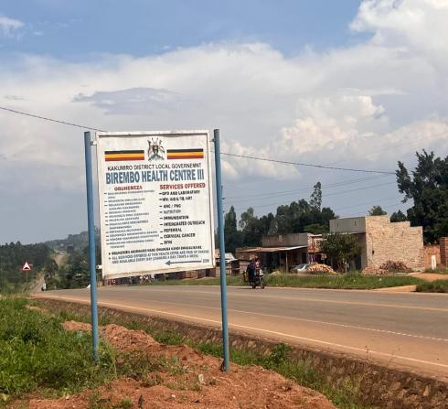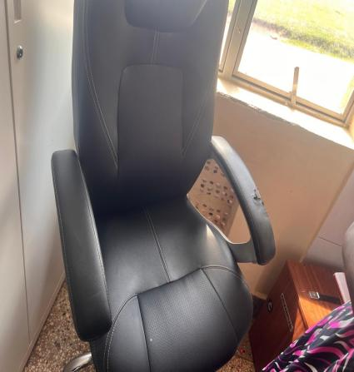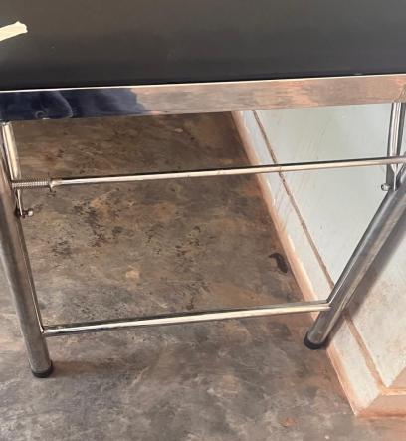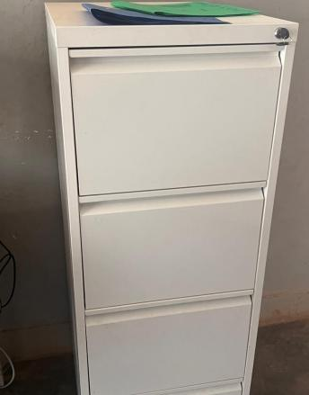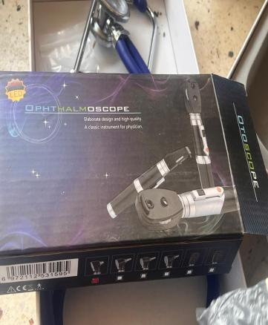
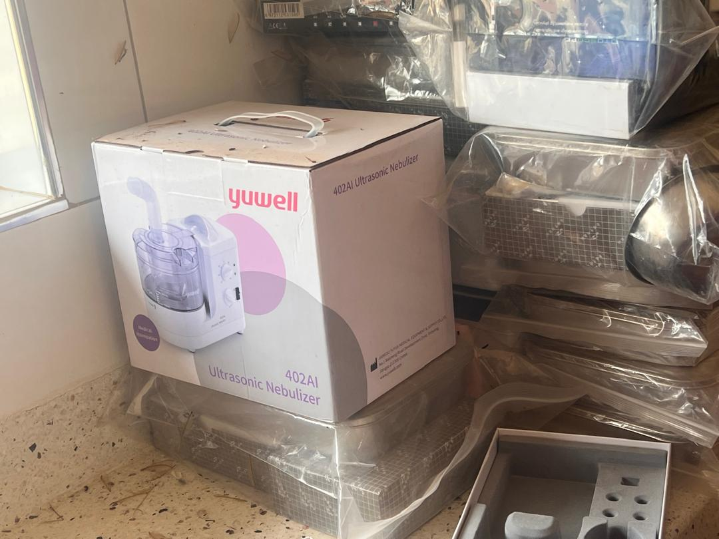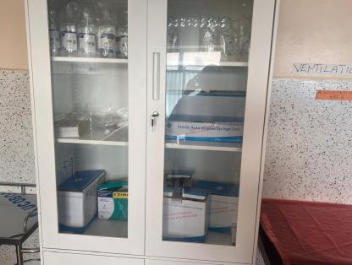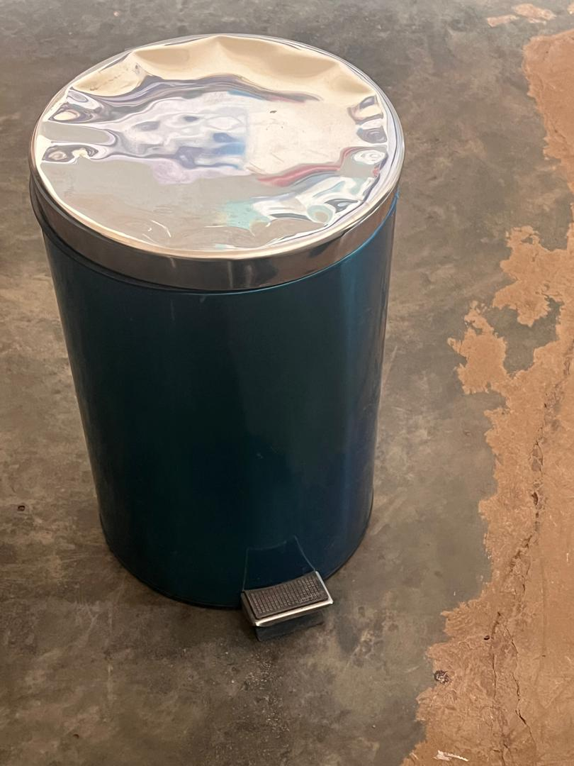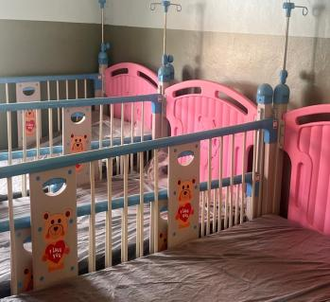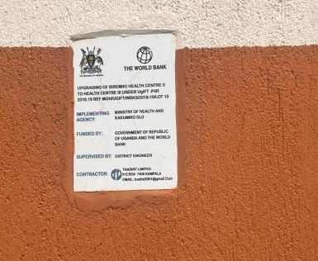
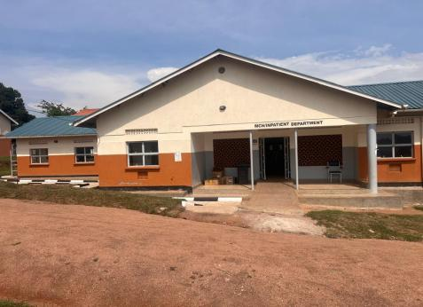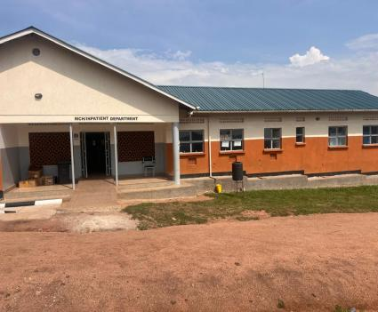

SCHOOL VERIFICATION CHECKLIST

SCHOOL INTERVIEW/DISCUSSION GUIDE

Name of school: ………………………………………………………………………………..

1a | Does the Facility have a record of all assets provided under UgIFT.  (Obtain a record and verify if it has the costs and numbers supplied
1b | If Not ask how many were supplied and when.

2 | How does this facility Maintain (repair/service/replace) the assets provided under Ugift

3 | Does the facility take regular record about functionality/ or breakdown of the assets provided?  Nonfunctional/ working, and reasons for non-functionality.

4 | How has the UgIFT support helped in service delivery in the area, any issues, challenges and any recommendations for better program implementation.

PROCEED TO VERIFICATION AFTER THIS DISCUSSION

SCHOOL FURNITURE
(School Desks, Office chairs, Laboratory stools, Book shelves)

Name of LG………………………………………………………………… Name of SCHOOL………………………………………………………………………………

Equipment/ Item | Department | Asset Number | Item  Description | Life in Months | Tag Number ( engrave no.) | Date Of Pur | Date Placed In Service | Recoverable cost | Cost | Acc Dep Cost | Net Book Value | Ytd Deprn | Equipment status | Remarks

ICT ITEMS TO VERIFY
(Desktop Computer, Server Processor, Network Switch 24 Port, Multipurpose Printer, UPS, Projector, Air Conditioners, Server, CCTV Camera)

Name of LG…………………………………………………………………………… Name of SCHOOL………………………….………………………………………

Equipment/ Item | Department | Asset Number | Item  Description | Life in Months | Tag Number ( engrave no.) | Date Of Pur | Date Placed In Service | Recoverable cost | Cost | Acc Dep Cost | Net Book Value | Ytd Deprn | Equipment status | Remarks

BUILDINGS TO VERIFY
(Non- Residential and Residential, Kitchen, Toilets/Pit latrine Water tanks, Fences etc.)

Name of LG…………………………………………………………………………… Name of SCHOOL………………………….………………………………………

Equipment/ Item | Department | Asset Number | Item  Description | Life in Months | Tag Number ( engrave no.) | Date Of Pur | Date Placed In Service | Recoverable cost | Cost | Acc Dep Cost | Net Book Value | Ytd Deprn | Equipment status | Remarks

